Polyglot Persistence
25th May 2025 R00225669 Rebecca Lordan
Research on Integrating MongoDB cluster with Neo4j with the Latest Version of DocManager
Option 2
Task: Write a short report to document the steps of setting up doc manager with neo4j. In the report, you need to indicate the version of your software and the operating systems you used. In the report, you need to prove that the connection is functioning with the diabetes self-deployed cluster example. (You need to answer three queries in the spec).
Operating System – Windows Version 10,0,26100,4061
Neo4j Version – desktop 5.24.0
MongoDB Version – 8.0 Community
APOC Version 5.24.0
Mongo-connector – 3,2,0
Neo4j_doc_manager – 0.5.1

Installing MongoDB
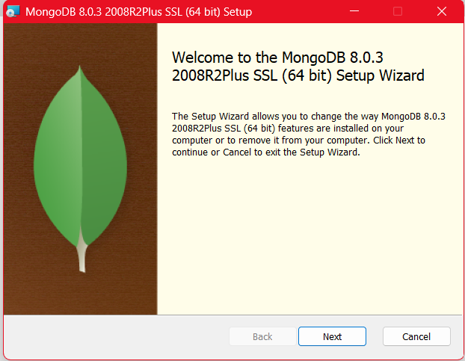
First you need to make sure that you have MongoDB running on the computers. You will need the MongoDB server (mongod.exe) and the shell installed. To download this is simple just go to the MongoDB Download Centre, and download it to your machine, the only thing is that you have to make sure to add MongoDB to your system PATH as this is what lets you run MongoDB commands from the command prompt without typing the full path.

Create the Data Directory
MongoDB stores its data files in a directory. It automatically looks for C:\data\db, but if this folder doesn’t exist, MongoDB will show an error when you try to start it.
It’s possible that you might have to import the data, to do this we use the mongoimport
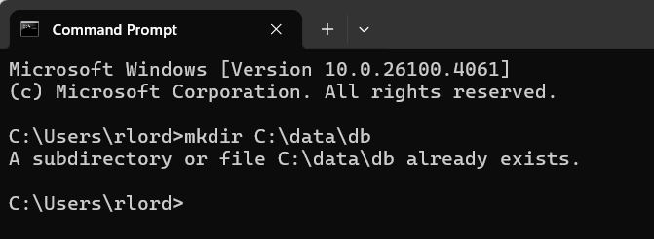
Starting MongoDB
Next, you’ll need to start the MongoDB server process so that it can listen for connections to store data. Drag and drop your mongod.exe "C:\Program Files\MongoDB\Server\8.0\bin\mongod.exe" --dbpath "C:\data\db" and hit enter. Minimise this and let it run in the background. If you close it, MongoDB will stop running.
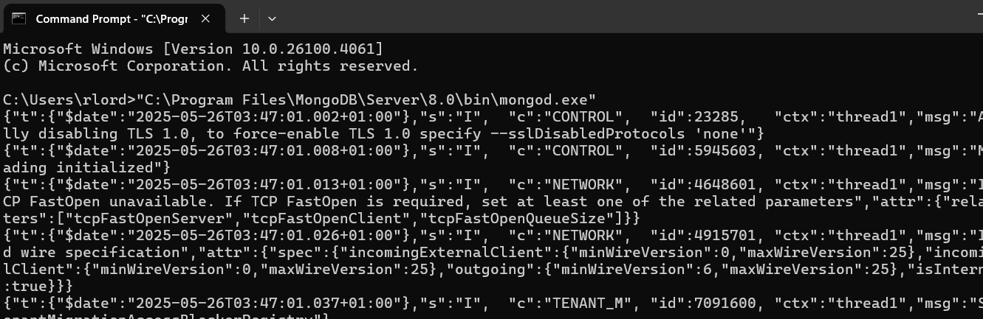
Connect to MongoDB
Open a new Command Prompt to start the MongoDB Shell and run mongosh, this will connect you to the running MongoDB server. You need this second terminal window to interact with MongoDB while the server is running in the first window.
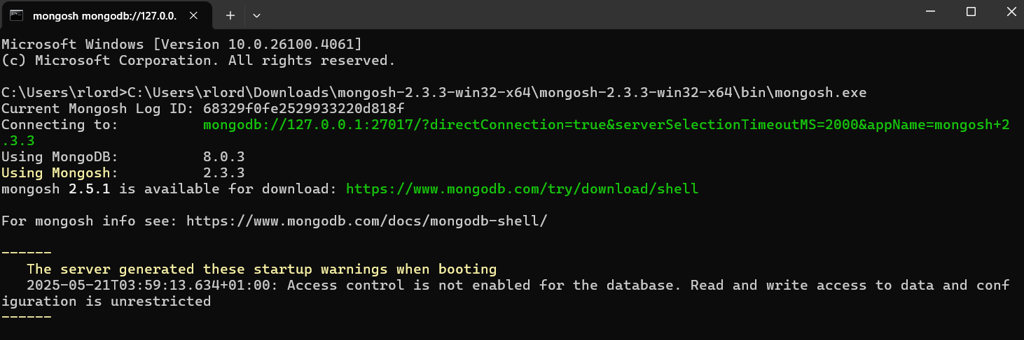
Importing the Diabetes Data
Download the diabetes_data.json file. In the MongoDB shell, create the database and import the data. This makes it so that you can use the diabetes dataset in the MongoDB.
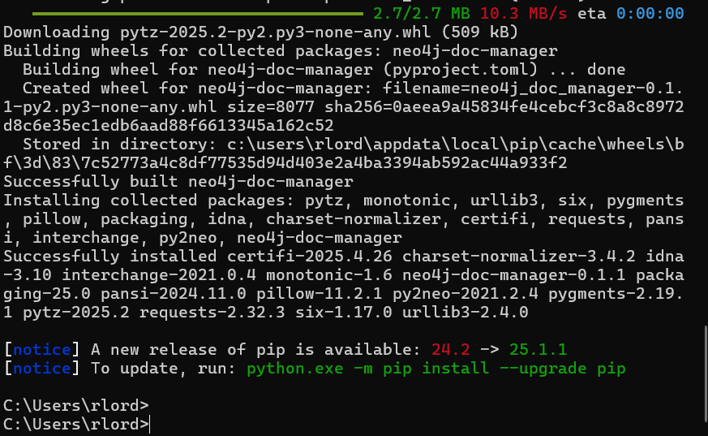
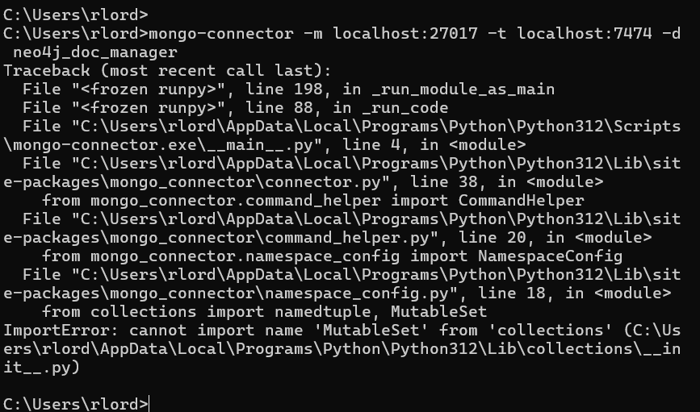

Check that your data is there
Just check that you have imported the data correctly. This also switches to your database and shows one document from your collection
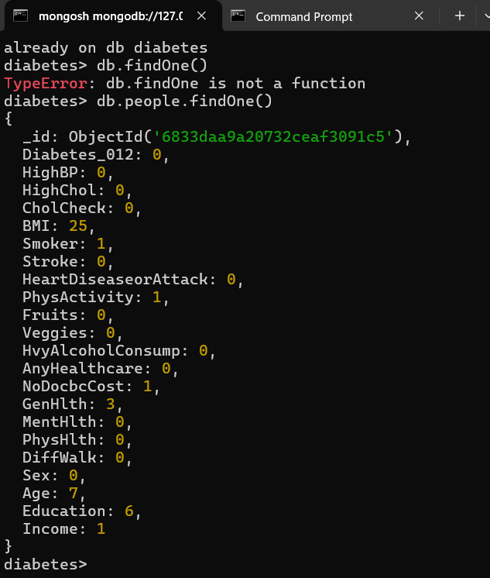

Setting Up Neo4j and APOC
Once MongoDb is up and running you can more onto Neo4j set up. Neo4j is a graph database, which means its good at showing relationships. Download and install it from neo4j.com, to install it in Neo4j Desktop, to your database then Plugins and Install APOC.
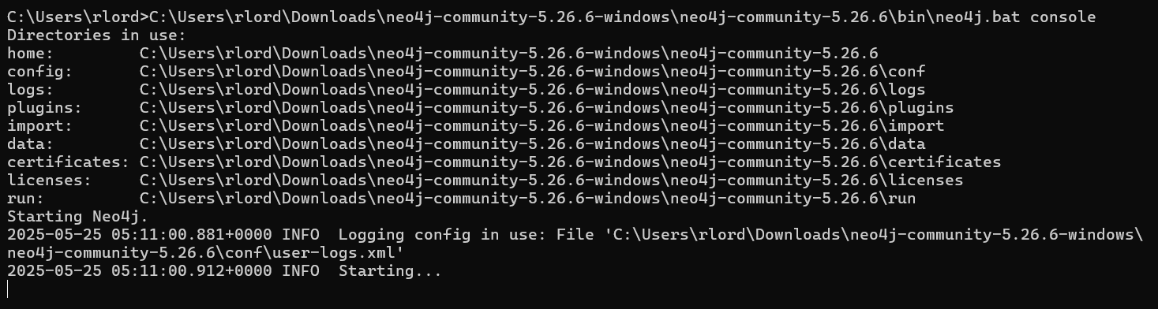
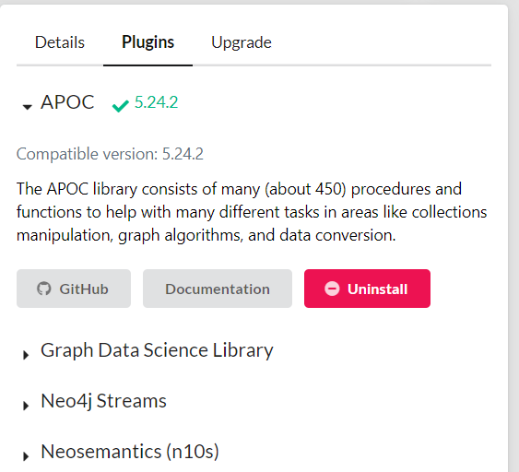
If you’re using Neo4j Desktop, make sure that your local database is started. Open the Neo4j Browser – Localhost:7474, log in with your Neo4j username and password.
Test APOC and MongoDB Connections, in the browser’s query box, run
Neo4j Graph Schema, each MongoDB document becomes a Person node, Properties are mapped directly, and relationships can be added later for more advanced graph queries.
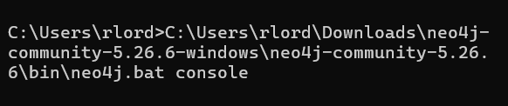

Installing mongo-connector and neo4j_doc_manager
Neo4j’s APOC library provides direct procedures to connect the MongoDB and import data, enabling seamless integration for analytics and graph modelling. This approach can be used as an alternative or complement to DocManager-based synchronization.
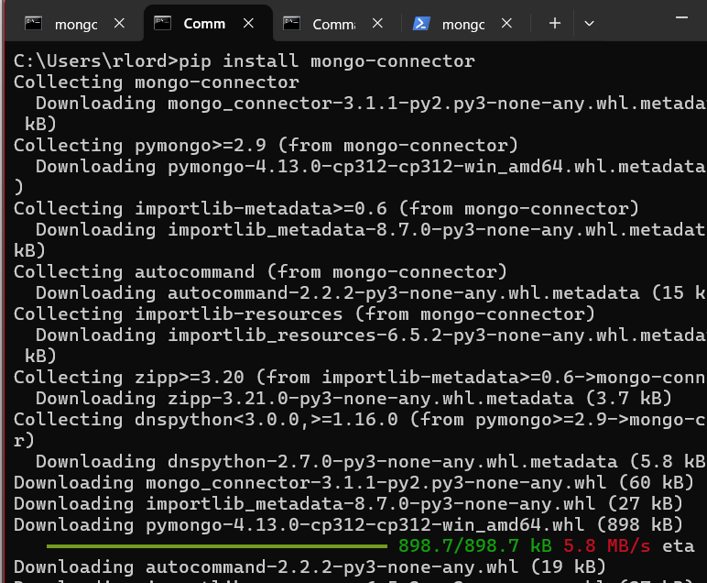
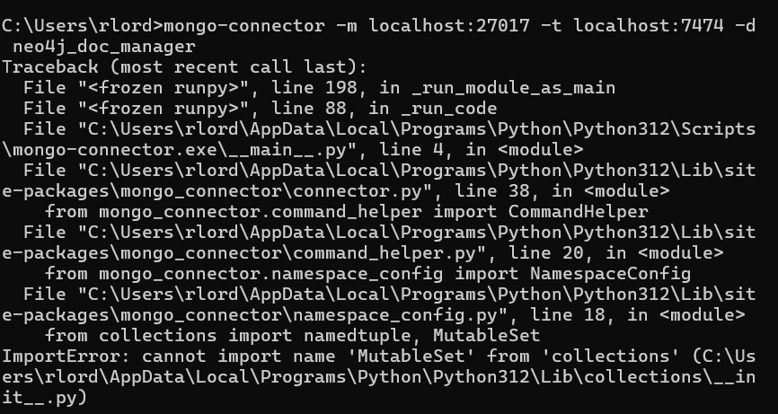

Setting up the Database and Collection
First create a new MongoDB database called and a collection. Import the records from the json file. This was done using the mongoimport aswell. After importing its good to run a command just to double check that everything was imported correctly
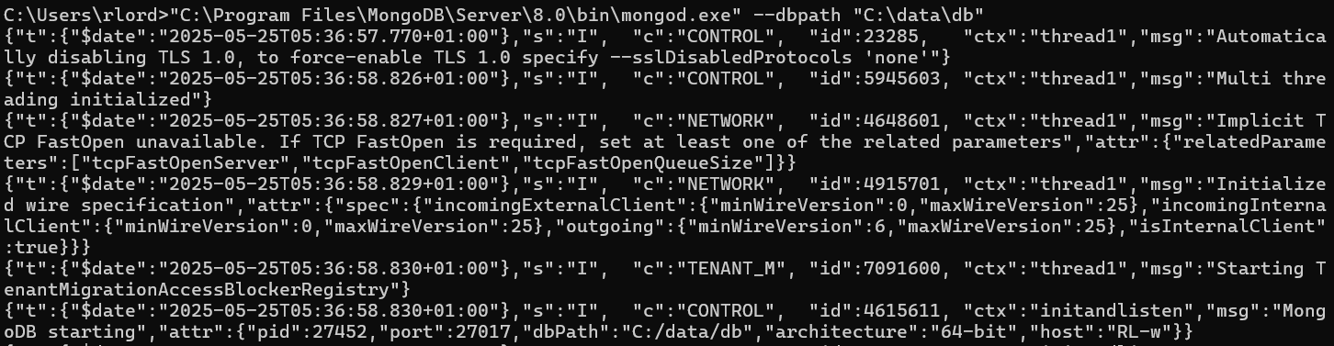
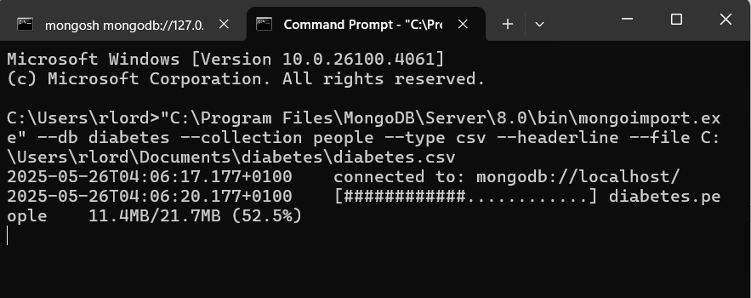
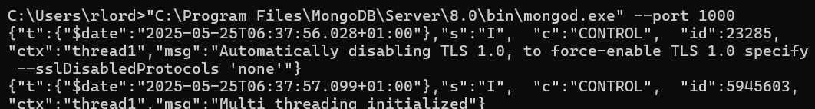
Installing and Configuring Neo4j with APOC
Install Neo4j and the APOC plugin, then enable APOC procedures in the configuration. APOC is required for Neo4j to connect to external data sources like MongoDB and perform advanced operation.
Configuring APOC to Connect to MongoDB
Set up the MongoDB connection details in Neo4j’s configuration file. This enables Neo4j to securely access and import data directly from your MongoDB cluster.
Importing Data from MongoDB to Neo4j
Use APOC procedures to pull and transform data from MongoDB into Neo4j as nodes and properties this transfer your diabetes data into Neo4j, making it available for graph-based analysis and queries
Designing the Neo4j Graph Schema
Define how the imported data will be structured, nodes, labels, relationships in Neo4j. A well-designed schema makes complex queries easier and more efficient, matching your analysis needs.
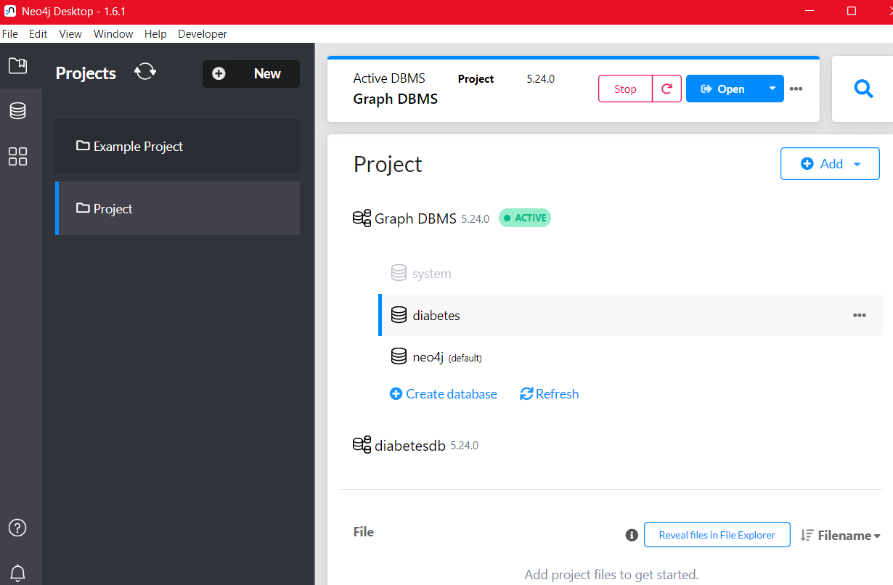

Testing the Connection with the Diabetes Cluster
By running basic queries to be sure that Neo4j can access and display data from MongoDB. This helps verify that the integration is working and that the data transfer was successful.
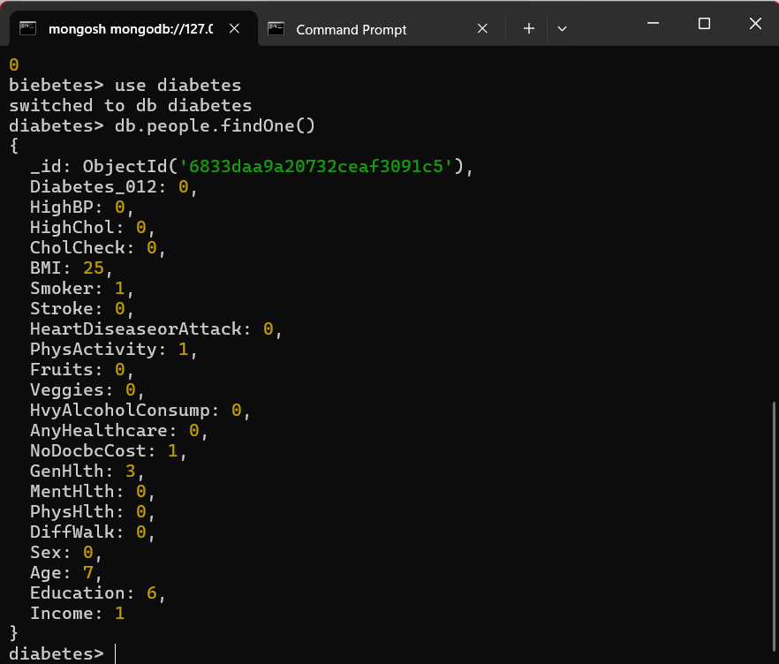

Queries
- Pregnant Young Women with Healthy Lifestyles
Find a women younger than 30, who is pregnant with a healthy lifestyle. The query below looks for Person nodes where, the person is female under 30 has is pregnant set to true and either has a Healthy Diet or Regular Exercise, If a person has all of these it will return the persons name, age and lifestyle
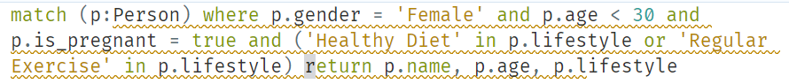
- Obese Male Pensioners with Poor Health and Low Income
Looks for a person where gender is male, obesity is true, age is greater than 65, has a health condition or poor health, has low income.
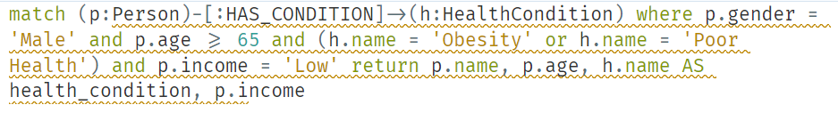
- Smokers with Diabetes and Multiple Risj Factors
Looks for a person where is_smoker is true, they have Diabetes, and they have multiple conditions like Obesity, Poor Diet
